# ACKNOWLEDGEMENT

I would like to thank Suzeet Chettri, Ramesh Gyawali. And I would also like to express my deep and sincere gratitude to Web Graphic Information Technology, Chabhil and the entire members for providing me the exciting opportunity to be one of them and giving me thorough guidance and opportunities to move ahead with my internship objectives.

Therefore, I consider myself as a very lucky individual as I was provided with an opportunity to be a part of it. I am also grateful for having a chance to meet so many wonderful people and professionals who led me though this internship period.

I would express my deepest thanks to MR Suzeet Chettri, (Director)/ [and Ramesh Gyawali, (Developer) for taking part in useful decision & giving necessary advices and guidance and arranged all facilities to make internship easier. I choose this moment to acknowledge his contribution gratefully.

I am deeply indebted to Orchid International College for stimulating suggestions and encouragement helped me in writing of this internship report.

………………………

Sumit Pradhan

BIM VIII semester

Orchid International College

Roll No.: 4142/12

T.U. Registration No.:7-2-0939-0058-2012

# DECLARATION

I hereby declare that the internship report entitled “An Internship report on Web Application”, submitted to Office of the Dean, Faculty of Management, Tribhuvan University is my original work done in the form of partial fulfillment of requirements for the Bachelor of Information Management (BIM) under the supervision of Ramesh Gyawali (Developer). This work is an independent work. The help taken from the other people has been mentioned on the acknowledgment. Any part of this report and the report as a whole therefore has not been submitted or published for the academic award of any other university or academic institutions.

………………………

Sumit Pradhan

BIM VIII semester

Orchid International College

Roll No.: 4142/12

T.U. Registration No.: 7-2-0939-0058-2012

# ABBREVIATION

BIM Bachelor of Information Management

GIS Geographical Information System

IBM International Business Machine

ICT Information and Communication Technologies

ISPs Internet Service Providers

IT Information Technology

NITC National Information Technology center

NTA Nepal Telecommunications Authority

QA Quality Assurance

TU Tribhuvan University

HTML Hyper Text Mark-up Language

CSS Cascading Style Sheet

PHP Hyper Text Pre-Processor

MySQL My Structured Query Language

JS JavaScript

UI User Interface

CMS Content Management System

# LIST OF FIGURE

Figure 1: Organization Hierarchy 3

Figure 2: Gantt Chart 3

Figure 3: Company Logo 8

Figure 4: Login Page 14

Figure 5: Admin Home Page 15

Figure 6: Content Management 15

Figure 7: Content Insertion 16

Figure 8: Content Update 16

Figure 9: Content Deletion 16

Figure 10: Index Page 17

Figure 11: Services Information 17

Figure 12: Customer Feedback Form and Other Information 18

TABle Of content

Contents

ACKNOWLEDGEMENT iii

DECLARATION iv

ABBREVIATION v

LIST OF FIGURE vi

CHAPTER -ONE 1

INTRODUCTION 1

1.1 Introduction 1

1.2 Objective 1

1.3 Methodology 2

1.3.1 Organization Selection 2

1.3.2 Placement 2

1.3.3 Duration 3

1.3.4 Activities 3

CHAPTER - TWO 5

INTRODUCTION OF INDUSTRY 5

2.1 Introduction to IT Industry 5

2.2 History of IT in Nepal 5

2.3 Importance of IT 6

2.4 Scope of IT 6

2.5 Opportunities and Challenges 7

CHAPTER - THREE 8

INTRODUCTION OF THE ORGANIZATION 8

3.1 Introduction to Webgraphic Nepal 8

3.2 Objective of Organization 9

3.3 Mission of Organization 9

3.4 Vision of Organization 9

3.5 Product and Types 9

3.5.1 Domain Registration 10

3.5.2 Website Design 10

3.5.3 Website Hosting & Maintenance 10

3.5.4 Mobile Application 10

CHAPTER - FOUR 12

ANALYSIS OF ACTIVITY DONE/ 12

PROBLEM SOLVED 12

4.1 Brief Description of Activity Done 12

4.1.1 Technologies learn 12

4.1.2 Learn hardcore programming approach 12

4.1.3 Work on Back End 13

4.1.4 Work on Front end 13

4.2 Activities that I performed 13

4.3 Basic Functionalities of the System 13

4.4 Snap Shots of Activity Done 14

4.4.1 CMS 14

4.4.2 Designing 16

CHAPTER - FIVE 19

CONCLUSION/ LESSON LEARNT 19

5.1 Conclusion 19

5.2 Lesson Learnt 19

5.3 Recommendation 20

BIBLIOGRAPHY 21

# CHAPTER -ONE

# INTRODUCTION

## Introduction

An internship consists of an exchange of services for experience between the student and an organization. Students can also use an internship to determine if they have an interest in a particular career, create a network of contacts. Some interns find permanent, paid employment with the organizations for which they worked. This can be a significant benefit to the employer as experienced interns often need little or no training when they begin regular employment.

Bachelor of Information Management is special purpose program which main theme is to develop result oriented Information Technology (IT) professionals. Today’s business environmentdepends on the Management andIT. BIM program helps to gain knowledge and enhance capabilities in both of these sectors i.e. IT and Management, for which I am interested too. So BIM become my firstpriority for higher education. The main focuses of this program are:

* Preparing IT professionals proficient in the use of computers and communicational techniques in order to develop effective information system to solve real life problems in the milieu.
* Developing students’ skill in object-oriented software design methods and data management system.
* Provide professionals training to student by combining information technology with managerial skills.

As a part of the BIM program, the college under Tribhuvan University authorizes this internship program with the motive of blending theoretical knowledge to practical experience. I accomplished this internship program at Web Graphic Information Technology, Chabhil. As stipulated by the University, the duration of internship was twomonths.

During the study period I have learn about the various programming language and get familiar with it. Which leads me to choose my future as a software developer so, I choose to do my internship in my interested field i.e. programming.

## 1.2 Objective



The objective of the internship is to experience the organizational culture and have real working experience and the main objectives of this internship is to acquaint the IT student like me with the reality of the organizations’ functioning and to undertake in depended analysis and the appraisal of the situation. The general objective of this internship is to partially fulfill the requirements for the degree BIM. The specific objectives of internship are:

* To provide students the opportunity to test their interest in a particular career before permanent commitments are made.
* To implement the theoretical knowledge acquired from college in real working environment.
* **To receive an introduction to an organization within the Information Systems industry and to gain a better understanding of its design and structure.**
* To maintain the public relationship among the staff & customers.
* To get career insights existing in the country.

However, the specific objectives of doing internship are as follows:

* To gainskills to work in different situation.
* To learn the programming skill.
* To learn to develop desktop application.
* To learn to work with databases.

## 1.3 Methodology

### 1.3.1 Organization Selection

Selection of organization for the internship program is always a crucial task. Being and IT student I am interested in software development. As an intern I wanted to be in the organization where my interest will be fully appreciated. So I select Web Graphic Information Technology as my destination.

At very beginning I request senior students of Orchid International College who is currently working as a developer in the organization. Then they suggest me to drop C.V (Curriculum Vitae) to the company HR (Suzeet Chettri).As per my interest this organizationdid select me as a developer through operational director. Web Graphic Information Technologywas the good choice as it had provided a very good learning environment.

### 1.3.2 Placement

In Web Graphic Information Technology, I was place in development department and given a task to develop a module of attendance system. I got prospect to engaged in following task

* Front End Development
* Back End Development

In three month period of I was supervised by developer. Following figure shows mine placement.

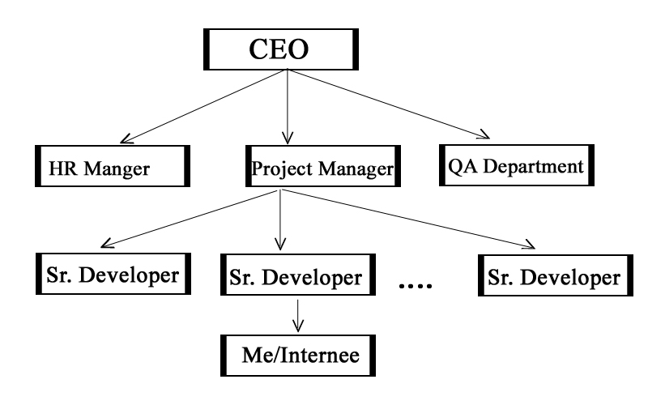

Figure : Organization Hierarchy

### 1.3.3 Duration

The requirement duration of internship for BIM, affiliated to Tribhuvan University, demands the time span of eight weeks. So I worked for following time frame:

Start date:June 03, 2016

End Date: August 02, 2016

Duration: 2 months

Office hour: 10:00am – 5:00pm

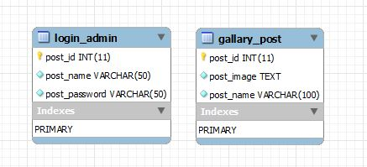

Figure : Gantt Chart

### 1.3.4 Activities

During internship period we often visit to the organization to know about the existing system and analyze for new requirement.Regular interviews were conducted with the authorize officials and staff members. After collecting all the relevant information, we start generating overall idea about the system, and prepare software as per the organization’s requirement. The lists of activities are as follows:

* Discussion in each stage so that chance of bug reduce.
* Testing of each feature.
* Agile based Development
* Discussion on each topic to reduce the conflict.
* Research and Development on new concept or requirement.
* Helping to solve error or bugs as well as research on it.
* Learned new features added to HTML, CSS and Javascript along with the perspective of photoshop application for designing
* Designed and developed different websites for clients and for practice in the organization.

The tools used for performing these activities are:

* Bootstrap for responsive designing
* Font-awesome for different icon
* Javascript for client side validation
* HTML 5
* CSS
* MySQL
* Xampp

# CHAPTER - TWO

# INTRODUCTION OF INDUSTRY

## 2.1 Introduction to IT Industry

Information Technology (IT) is the application of computers and telecommunication equipment  to store, retrieve, transmit and manipulate data, often in the context of a business or other enterprise.

The term is commonly used as a synonym for computers and computer networks, but it also encompasses other information distribution technologies such as television and telephones. Several industries are associated with Information Technology (IT), including computerhardware, software, electronics, semiconductors, internet, e-commerce, telecom equipment computer services.

Based on the storage and processing technologies employed, it is possible to distinguish four distinct phases of IT development: pre-mechanical, mechanical, electromechanical and electronic. This article focuses on the most recent period (electronic), which began in about 1940.

## 2.2 History of IT in Nepal

The history of IT and computers in Nepal dates back to not more than a couple of decades. However, the growth of Information Technology here has been rapid. The major leap towards the advancement in this field started when the first computer International Business Machine(IBM) 1401, a second generation mainframe computer, was used in the 1971 census, although an electronic calculator called ‘Facid’ was used before in the 1961 census. Again, another second generation mainframe computer International Computers Limited (ICL) 2950/10 was used for the 1981 census.

The credit for introducing internet among the people mainly goes to the private sector.  Although the internet was initially limited only to email services, in 1995, a company Mercantile Communications finally started the internet services in the country. In 1998, Nepal Telecommunications Authority (NTA), a telecommunications regulatory body, was formed as per the Telecommunications Act 1997. NTA holds the power to issue license to the Internet Service Providers (ISPs) in Nepal.

National Information Technology center (NITC) was established in the year 2002 in line with IT Policy 2002 as a premier organization of Nepal Government in Information and Communication Technologies (ITC) sector situated in Singhadurbar, Kathmandu. Being an implementing agency for Government of Nepal, NITC acts as a focal point for implementation of government e-Services. Having a data center of its own, it provides a one- stop solution for server co-location for government agencies with its government network as a backbone. Providing e-services (e.g. Business License portal, E-Gatepass system, E- procurement etc.), hosting the government websites, managing mail servers and government’s domain registration service are among the many critical services NITC is responsible for.NITC focuses on technology enabled applications to bridge digital divide and ultimately to overcome monumental challenges in development of e-Governance.

## 2.3 Importance of IT

* With the help of IT, communication has also become cheaper, quicker and more efficient. The internet has also opened up face to face direct communication from different parts of the world.
* IT has helped computerize the business process thus streamlining businesses to make them extremely cost effective money making machines. This in turn increases productivity which ultimately gives rise to profit that means better pay and less strenuous working condition.
* IT has made it possible for businesses to be open 24 x7 for businesses all over the globe.
* IT is the creation of new and interesting jobs. Computer programmers, System analyzers, Hardware and Software developers and Web designers are just some of the many new employment opportunities created with the help of IT.
* Information technology is used for storing, protecting, processing, securing, transmitting, receiving and retrieving information.

## 2.4 Scope of IT

Modern society is becoming more and more reliant on the use of technology and this has indeed created the demand of expert in the field of Information and Technology. Thus, IT has become one of the most popular subject choices for the students.

Moreover, the ever dynamic world of Information and Technology Communication (ITC) requires subtle and comprehensive expertise in computer technology, telecommunication and multimedia as well as in the knowledge of networks. Modern world has witnessed the IT revolution due to the advancement of knowledge in these disciplines and these disciplines are closely aligned to one another. IT professionals who can make a difference are keenly sought after by different types of leading organization throughout the world. So the prospect of careers in IT is reasonably good.

IT graduates can work in different industry like software industry, financial institution, health, corporate organization etc. The following are the list of common career for IT graduates.

* System Analyst
* Project Manager
* Software Developer
* Web Developer
* Web Designer
* Database Developer
* QA(Quality Assurance) Officer
* Technical Writer

## 2.5 Opportunities and Challenges

Some challenges are:

* Network security is by far the greatest concern for many companies.
* Insufficient allocation of Budget.
* Not sufficient manpower for developing IT industry.
* Skilled manpower are outsourcing to other countries.

Some opportunities are:

* Technological advances had resulted in dramatically lowering costs of electronics.
* Borderless world as a result of globalization.
* New applications have given rise to new ways of entertainment (i.e. online gaming) and socialization (i.e. chat rooms).

# CHAPTER - THREE

# INTRODUCTION OF THE ORGANIZATION

## 3.1 Introduction to Web Graphic Information Technology

Web Graphic Information Technology is an out sourcing company of Sydney based small and medium sized business, an e-solutions company engaged in web development, web designing , domain registration, web hosting , search engine submission/ promotion, search engine optimization, web management, online shopping carts development, internet marketing web applications, online information management systems database driven portal and so on.

Web Graphic Information Technology is the perfect combination of creativity and credibility. Web Graphic Information Technology provides web designing services. Web Graphic Information Technology’s web solution offers internet presence that reflects ideas in the web site and meets the objectives by capturing the attention of the business world. If any business needs to get their business noticed, we are there to help them establish their business on the World Wide Web.

Our expert team of web developers will give interactivity and creativity to the web sites of portals, which will give a positive impact on the targeted customers. We have developed and implemented successful solutions for our consumers. We work for business Integration and data management. We exercise our web expertise to work for them and build up their company’s future. Our team fo dedicated professionals takes the business beyond the boundaries. Our aim is to build neat, professional, interactive and good looking websites. We complete our projects in time and build relationships with our valuable clients through ethical business practices. We provide reliable choices at comparative prices.

We offer services to our valuable clients as per their needs and choices. We excel IT rendering services to corporations as well as individual owned business.



Figure : Company Logo

## 3.2 Objective of Organization

## 1. While Designing and developing the site, we try to maintain standards.

## 2. We provide portable and compatible website solutions.

## 3. Modifications and upgrades can be done by re-designing the site.

## 4. The aesthetic appeal of the design and layout of a website attracts internet surfers and compels them to visit the site frequently.

## 5. End users simulation is performed to ensure user-friendly navigation and flow.

## 6. State of the art technology is used to ensure optimum performance.

## 3.3 Mission of Organization

We specialize in Website development, Web hosting, Website maintenance and marketing, Search Engine Optimization (SEO), Responsive website designing, Mobile application development, iOS app, Android apps and other IT solutions.

## 3.4 Vision of Organization

We are a well-established company making e-power affordable even for small business houses without compromising quality. We are known for our creativity, punctuality and ability to fulfill our customers' demand and obviously quality uncompromised. Our after sales service is what makes our customers look for no other place.

## 3.5 Product and Types

The types of product that are developed by Web Graphic Information Technology are as follows:

### 3.5.1 Domain Registration

### The first and foremost step before we go online is getting a name for our website. Securing a domain name after our business name is a smart move. Web Graphic Information Technology can help in getting the domain name. When we get a name from company, we don’t just get the name but also a customized sample home page website layout for our business website. Also company will be making changes to the layout as per our needs and requirements till we get what we’re looking for.

### 3.5.2 Website Design

### Web Graphic Information Technology provide all aspects of website designing service that range from single-page design to database driven classified or ecommerce websites and shopping cart software. Company have a team fully motivated and capable of creating customized layouts and software at affordable prices. Company can work on any given platform. As per the request of customers company can prepare the websites in any framework. Whether we want our website to be done using Wordpress, Joomla, Magento, Woocommerce or any other open source, we can help get what deserve the best.

### 3.5.3 Website Hosting & Maintenance

### Website maintenance services include quarterly (at a minimum) meetings to assess the state of our website and ensure that our online activities remain in line with our overall business goals. This website maintenance service also includes day-to-day programming, design, development, and marketing needs that our website may require.

### 3.5.4 Mobile Application

### With the development in the field of IT, mobile apps have been one of the most significant inventions. Whether you are looking to get an application developed for your store and display your products or you want your app to be informative, we can help you in getting apps as per your requirements. We specialize in building mobile apps, iPhone apps, android apps etc.

### 3.5.4 Search Engine Optimization

## As an Internet marketing strategy, SEO considers how search engines work, what people search for, the actual search terms or keywords typed into search engines and which search engines are preferred by their targeted audience. Optimizing a website may involve editing its content, HTML and associated coding to both increase its relevance to specific keywords and to remove barriers to the indexing activities of search engines.

# CHAPTER - FOUR

# ANALYSIS OF ACTIVITY DONE/

# PROBLEM SOLVED

## 4.1 Brief Description of Activity Done

The activities that are done during three month internship are as follows:



### Technologies learn

### There are a lot of technologies that are used in development environment which I learned on few weeks so that I upgrade myself to a level through which I can able to work on real time environment. Some of the technologies are

* HTML
* CSS
* Bootstrap
* Web service
* Font-awesome
* Javascript
* PHP programming
* Database MySQL

### Learn hardcore programming approach

After getting some knowledge on above technologies, my supervisor conformed that I am ready to work on the real time environment and he guided me on below things:

* Proper naming conversion for class, variable, pages.
* Techniques and innovating approach for conceptual level programming
* Presentation skills and way to make client or trainee understand everything that is being delivered to them as a part of technological knowledge.
* Error debugging process
* Managerial and motivation skills to staff with their proper management
* Time management in software development field.

### Work on Back End

### As we study in our database subject also, Database is the first step to work on any development area. Since the store mechanism of data play a vital role and minor defect or change on database bring whole project down. Therefore, we all engage in creating the entity and defining their relationship and this task is one of the major task in Software Development Area. In this we perform below activities:

* CRUD Operation
* Validation (empty field checking)

### Work on Front end

### Aftersuccessfulcompletion of back End,we work on front end to provide a user interface. The Below activities are performed in front End:

* Use of bootstrap to provide good and flexible looking for all devices.
* Use of Font-Awesome to provide icons and other good font.
* Use Captcha for form validation.

## Activities that I performed

Below are the activities that I have performed on this project:

1. Designing of templates for successfully implementing them in web based HTML.
2. Worked on bugs solving by using element inspection, facility provided by the browser itself.
3. Practiced slicing the templates by using CSS and HTML.
4. Client side validation using Javascript.
5. Used macromedia dreamweaver provided by Adobe Company.
6. Used transitions and animation property of CSS3.

## Basic Functionalities of the System

* Authenticate
* Helps to perform operation in digitalized form
* Recording and display the detail content of site

## Snap Shots of Activity Done

## There are two different activity that I have perform on company which is CSM and Designing.

### CMS

#### Login Page

### This is the starting page of the web. It authenticates the user and to log in to the system and make necessary changes. Admin can change or modify the content.

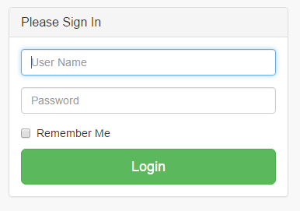

Figure : Login Page

#### Admin Home Page

In this page, admin page is opened and admin can manage his site by inserting, updating, and deleting the content of the site. Also admin profile can be edited.

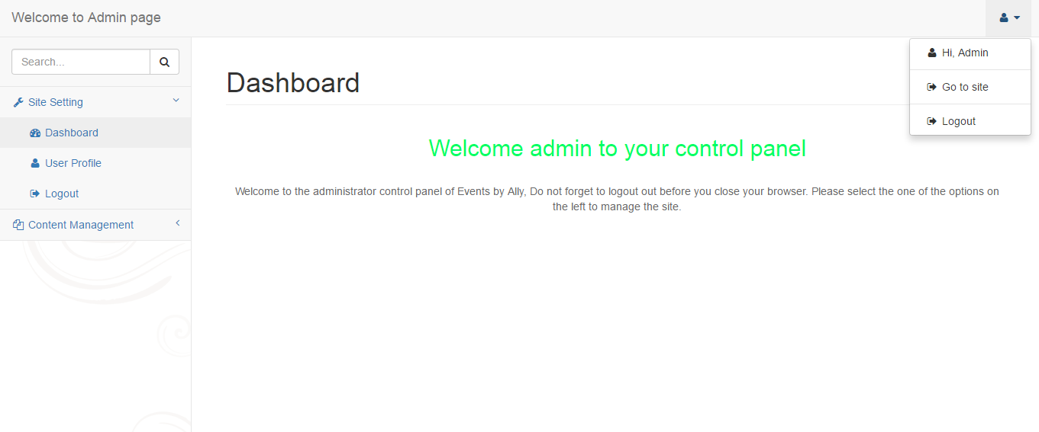

Figure : Admin Home Page

#### Content Management

In this page, admin can manually manage the content of his site like inserting the new record, updating the content i.e. to b change and delete the content as required as shown in figure below:

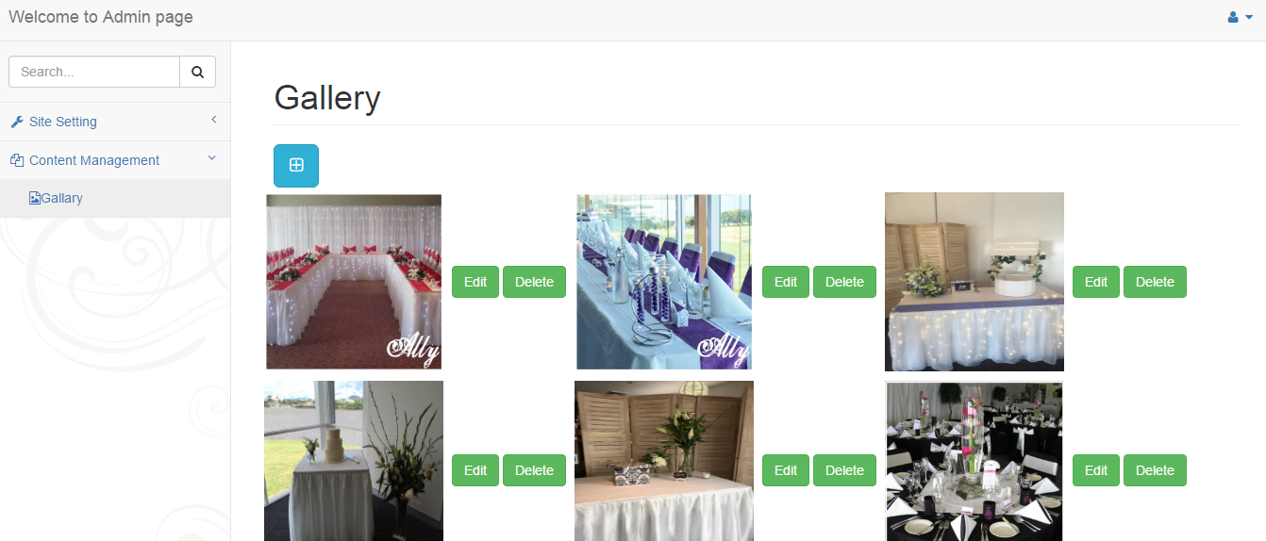

Figure : Content Management

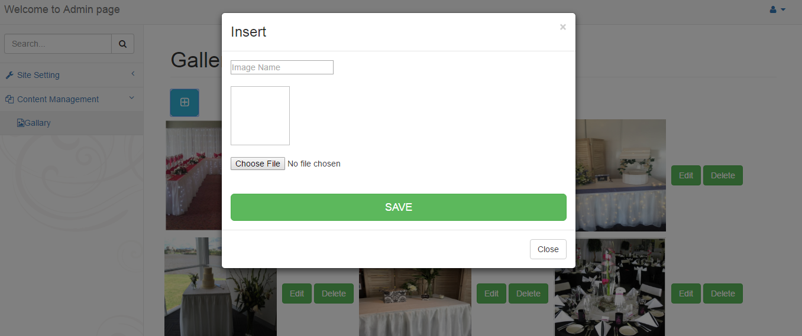

Figure : Content Insertion

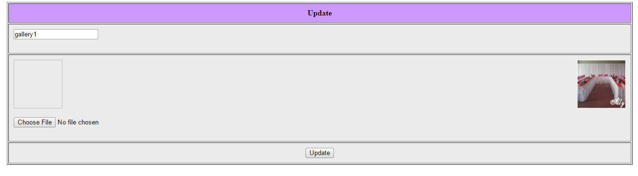

Figure : Content Update

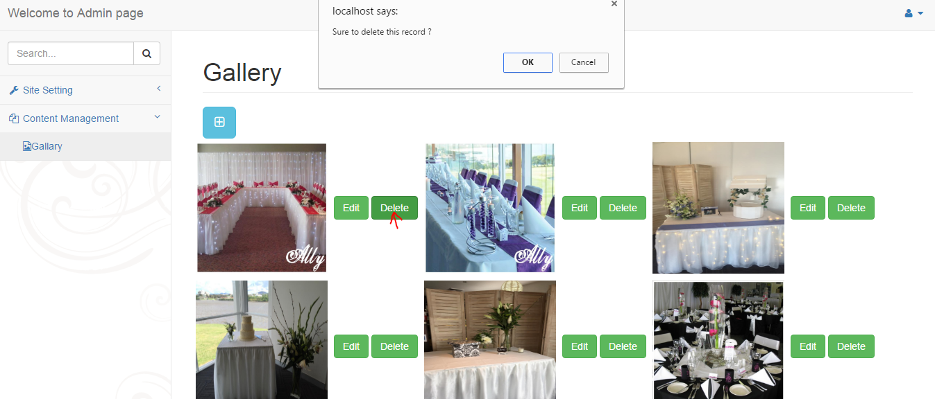

Figure : Content Deletion

### Designing

#### Index page

This the first look of the page, including slider, menu bar and link of site social media (facebook, twitter) is provided. It also contain different page link on the menu.



Figure : Index Page

#### Services Information

In this page, company services information is provided for the customer that can get.

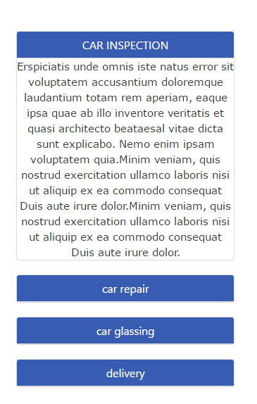

Figure : Services Information

#### Customer Feedback Form and other information

In this page customer can give the feedback or message to the company and also suggestion for the company.

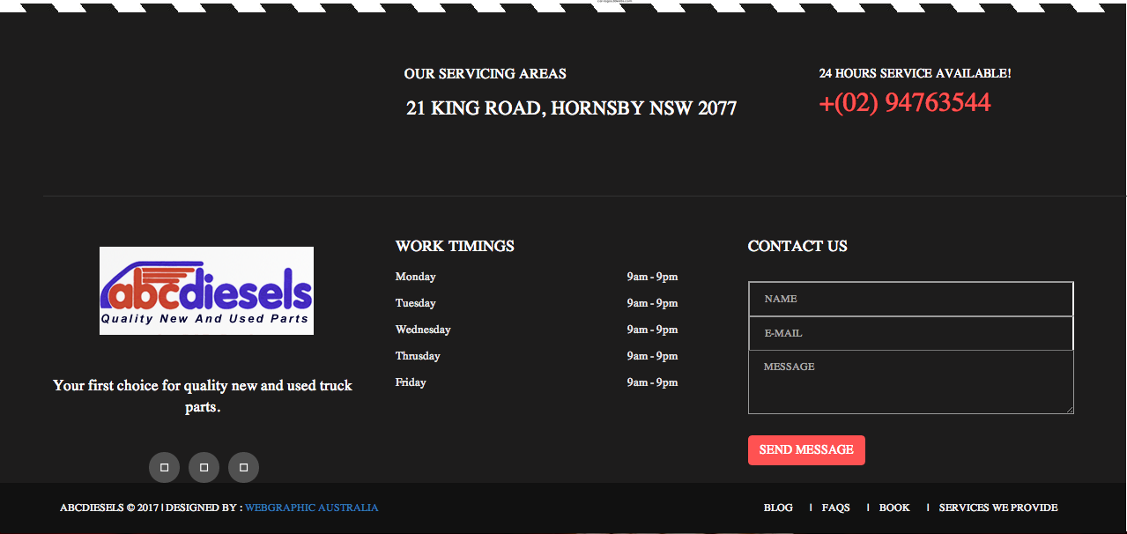

Figure : Customer Feedback Form and Other Information

# CHAPTER - FIVE

# CONCLUSION/ LESSON LEARNT

## 5.1 Conclusion

It was a wonderful experience to work in Web Graphic Information Technology with highly professional group of people. It was a great opportunity to learn about the professional environment and develop a professional attitude. The way one person helped the other and the whole department functioned together showed how a group of professional work together to meet a desired goal. The importance of good leadership among the managers and discipline among the staffs is must for smooth functioning of any organization or any department within it. Similarly good communication skill among all the staffs is also a necessity for the growth of any organization. It will certainly go as a confidence boosting factor in coming days.

## 5.2 Lesson Learnt

The content that I have learned is CMS(Content Management System) and Designing (Responsive). A Web CMSis perfect for creating and managing a website. It allows multiple editors to create and edit web content, it lets us create menus, sidebars, pages, sections and feedback forms, it manages user comments, and it helps us setup web blogs and serve their posts in reverse chronological order. It can also load (and configure) themes that change how our website appears to our users.

A sampling of the types of content that can be stored and distributed via a

CMS includes:

• simple pages

• complex pages, with specific layout and presentation

• dynamic information sourced from databases, etc

• training materials

• online manuals

• general business documents

• thousands of pages in total

• extensive linking betweenpage

In this track, I have learn how to design and build beautiful websites by learning the basic principles of design like branding, color theory, and typography which are all instrumental in the design process of a website. I have also learn HTML and CSS, which are the common code languages that all modern websites are built on. These are useful skills to acquire as they are needed by nearly every single business in the world to communicate to customers.Responsive web design is the practice of building a website suitable to work on every device and every screen size, no matter how large or small, mobile or desktop. Responsive web design is focused around providing an intuitive and gratifying experience for everyone. Desktop computer and cell phone users alike all benefit from responsive websites. By the end of this track, I have all the skills required to design and build our own websites or even start a career with one of the thousands of companies that have a website.

## 5.3 Recommendation

## After our college Orchid International College told us that it was a time period for internship, I myself approached to the organization. And drop my CV on the company, Human Resource Manager Mr. Suzeet Chettri. On the supervision of HRM, he provided me opportunity to work with his team and providing me with platform for the level of technological understanding.They thought me to be productive to their organization and work according to organization policy.

# BIBLIOGRAPHY

* http://www.w3schools.com/html/html5_intro.asp
* http://www.w3schools.com/css/default.asp
* http://www.w3schools.com/js/default.asp
* http://www.w3schools.com/php/default.asp
* http://www.w3schools.com/bootstrap/default.asp
* http://www.w3schools.com/sql/default.asp

# 